C Programming Language

**C language** Tutorial with programming approach for beginners and professionals, helps you to understand the C language tutorial easily. Our C tutorial explains each topic with programs.

The C Language is developed by Dennis Ritchie for creating system applications that directly interact with the hardware devices such as drivers, kernels, etc.

C programming is considered as the base for other programming languages, that is why it is known as mother language.

It can be defined by the following ways:

1. Mother language
2. System programming language
3. Procedure-oriented programming language
4. Structured programming language
5. Mid-level programming language

# History of C Language



**History of C language** is interesting to know. Here we are going to discuss a brief history of the c language.

**C programming language** was developed in 1972 by Dennis Ritchie at bell laboratories of AT&T (American Telephone & Telegraph), located in the U.S.A.

**Dennis Ritchie** is known as the **founder of the c language**.

It was developed to overcome the problems of previous languages such as B, BCPL, etc .Initially, C language was developed to be used in **UNIX operating system**. It inherits many features of previous languages such as B and BCPL.

|  |  |  |
| --- | --- | --- |
| **Language** | **Year** | **Developed By** |
| Algol | 1960 | International Group |
| BCPL | 1967 | Martin Richard |
| B | 1970 | Ken Thompson |
| Traditional C | 1972 | Dennis Ritchie |
| K & R C | 1978 | Kernighan & Dennis Ritchie |
| ANSI C | 1989 | ANSI Committee |
| ANSI/ISO C | 1990 | ISO Committee |
| C99 | 1999 | Standardization Committee |

Let's see the programming languages that were developed before C language.

Features of C Language

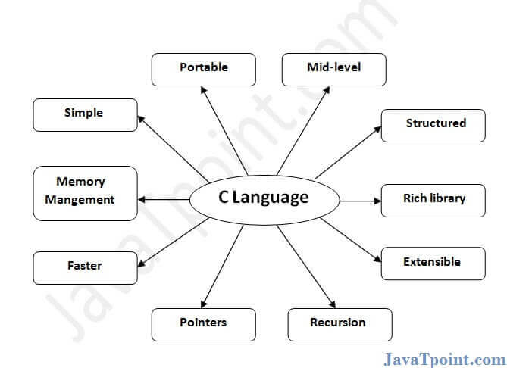

C is the widely used language. It provides many **features** that are given below.

1. Simple
2. Machine Independent or Portable
3. Mid-level programming language
4. structured programming language
5. Rich Library
6. Memory Management
7. Fast Speed
8. Pointers
9. Recursion
10. Extensible